|  |  |  |
| --- | --- | --- |
| **LAB221 Assignment** | **Type:** | **Short Assignment** |
| **Code:** | **J2.S.P0019** |
| **LOC:** | **40** |
| **Slot(s):** | **1** |

**Title**

Distributed Banking System- RMI

**Background Context**

When you withdraw some money from ATM, the information of your account will be sent from ATM machine to the bank, that included the account’s information like account number, balance, transaction type,…if we can pack all of them into an object, we need to send transaction object to the bank, validate the account before doing any transaction. This assignment will guide you how to work with objects in network application.

**Program Specifications**

Create an application for both client and server side.

**1. Main.java - for client side**

Can be a frame or console application, where users can select transaction type and do the transactions.

**2. Main.java – for server side**

Program the server side so that users can do the transactions.

***Function details:***

1. Display the prompt to inform users to accept information of account.
2. Server will check and valid information of account (list of all accounts can be saved on server side in a file)
3. If the account is valid, now users can select and do corresponding transaction.

***Expectation of User interface:***

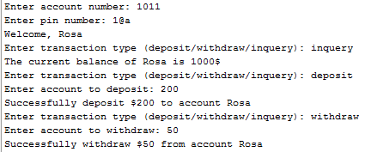

**Guidelines**